C29PE Tutorial 1 - Questions

- Economists study many issues, but all of them stem from the central economic problem of scarcity. Scarcity arises because there are constraints for both consumers (e.g. limited time, information and income) and sellers (e.g. limited resources to produce goods and services, perhaps because of a shortage of skilled labour). Some people suggest that the problem of scarcity will eventually disappear with the development of new technology and resulting higher levels of production.

- Is this statement true or false? Set out your thinking.

b) Because of scarcity we have to make choices about which goods and services we desire most.
i) Explain the concept of opportunity cost.
ii) What is the opportunity cost of you attending today’s tutorial?

.

- According to the Structure–Conduct–Performance paradigm, what determines business performance?

- You won a free ticket to see a concert tonight. You cannot re-sell the ticket. On the same night your favourite sports team is playing, and watching your team play is the only other activity you are considering tonight. You must therefore decide whether to watch the concert or watch your team play. The ticket to watch your team play costs £40 and you are willing to pay as much as £50 for the chance to see your sports team perform. What is your opportunity cost of going to the concert? (Hint: if you give up watching your sports team what is the value of your sacrifice?)

Sample exam questions

- A retailer of winter clothing purchases winter coats from a supplier at £200 per coat. During the winter season, the coats will sell at prices higher than £200 per coat. After winter is over, the retailer finds that there are still some remaining stock of winter coats that are still unsold. However, the unsold coats are no longer in demand after winter. The retailer has an option to re-sell these winter coats to the supplier at a 60% discount of the original purchase price of £200.
- Before the retailer purchased any winter coats from the supplier, what is the opportunity cost of buying the winter coats from the retailer?
- After purchasing the winter coats from the supplier, what is the retailer’s opportunity cost of selling the coats to a customer?
- As winter is about end, the retailer finds that there is a large stock of unsold winter coats. The retailer has been selling winter coats to customers at £800/coat. The store manager argues that the price should be reduced to £95/coat and try to sell the remaining coats before they become redundant after winter. However, the owner of the retailer disagreed as this would mean selling at a loss of £105 (£200-£95) per coat. Which argument makes economic sense? The store manager’s argument or the retail shop owner’s argument?

- The manager of a firm that producers coffee beverages is considering whether to increase the price of its products. The manager is concerned about how much demand will fall if price increased.

- Define price elasticity of demand and describe why it is a useful tool for firms.

- Use the mid-point formula to calculate the price elasticity of demand for coffee if the number of cups demanded falls from 500 to 350 cups per month when the average price is increased from £15 to £25.

(i) Interpret the price elasticity of demand coefficient calculated in part b). (ii) Identify one of the main factors determining the price elasticity of demand for the designer trainers?

- Calculate what will happen to total revenue if the manager decides to go ahead with the price change detailed in part b). Suggest an alternative option to increasing price if the firm wants to try and increase total revenue.

Supplementary questions (will not be discussed in class)

- How will the market demand curve for a ‘normal’ good shift (i.e. left, right or no shift) and what will happen to the equilibrium price in each of the following cases?

- The price of a substitute good falls
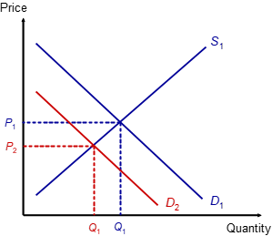

- The population rises

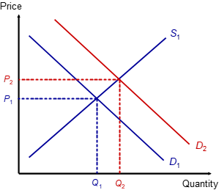

- Tastes shift away from the good
- The price of a complementary good falls
- The good becomes more expensive

- How will the market supply curve of a good shift (i.e. left, right or no shift) in each of the following cases? What will happen to the market price and the quantity traded.

- Costs of production fall .

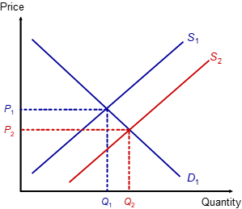

- Alternative products (in supply) become more profitable

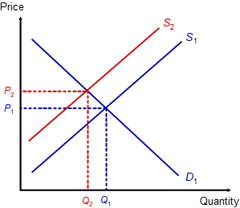

- The price of the good rises.
- Firms anticipate that the price of the good is about to fall.
- The demand and supply schedules for wheat in a free market are as follows:

Price per tonne (£) | 120 | 160 | 200 | 240 | 280 | 320 | 360 | 400
Tonnes demanded per week | 725 | 700 | 675 | 650 | 600 | 550 | 500 | 425
Tonnes supplied per week | 225 | 300 | 400 | 500 | 600 | 750 | 1000 | 1300

- Draw the demand and supply curves on a diagram:

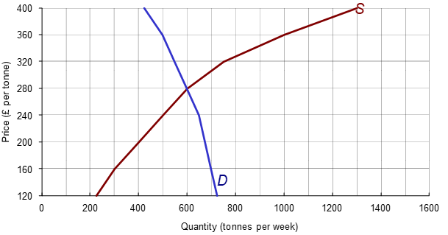

- What is the equilibrium price and quantity traded?
- Suppose the government fixes a maximum price of £200 per tonne. What will be the effect?
- Suppose that supply now increases by 150 tonnes at all prices. Enter the new figures.

Price per tonne (£) | 120 | 160 | 200 | 240 | 280 | 320 | 360 | 400
Tonnes demanded per week | 725 | 700 | 675 | 650 | 600 | 550 | 500 | 425
(old) Tonnes supplied per week | 225 | 300 | 400 | 500 | 600 | 750 | 1000 | 1300
(new) Tonnes supplied per week

- How much will price change from the original equilibrium (assuming that the government no longer fixes a maximum price)? How much more will be sold?

